TNSDC – IBM AGENTIC AI PROJECT

AI E-Commerce Customer Support Agent

An Agentic AI system for personalized learning, question answering, and quiz generation

Project Type | Agentic AI Mini Project
Selected Use Case | Use Case 3– AI E-Commerce Customer Support Agent
Core Capabilities | Memory + Tool calling
Development Duration | 4 -day project

Student Name | THISON BERO.K
Register Number | 422223243056
Department | B.TECH ARTIFICIAL INTELLIGENCE AND DATA SCIENCE
College | SURYA GROUP OF INSTITUTIONS, VIKKIRAVANDI

Academic Year: 2026

1. Project Overview

1.1 Project Title

Al E-Commerce Customer Support Agent

1.2 Problem Statement

E-commerce platforms receive a large number of customer queries related to orders, products, payments, delivery, returns, refunds, cancellations, and account-related issues. Handling these queries manually can be time-consuming and may result in delayed responses.
Traditional customer-sup
port systems often depend on predefined rules or FAQs. They may not understand the customer's complete request or provide personalized responses.
Therefore, there is a need for an AI-powered customer support agent that can understand customer queries, identify their intent, retrieve relevant information, and provide accurate responses automatically.

1.3 Brief Description of the Project

The AI E-Commerce Customer Support Agent is an Agentic AI-based system designed to assist customers with common e-commerce queries.
The agent uses natural-language processing and AI reasoning to understand customer requests. Depending on the query, it can provide information about orders, delivery, returns, refunds, products, and other support-related topics.
The system aims to reduce the workload of human support teams while providing customers with fast, consistent, and helpful assistance.

2. Objectives & Proposed Solution

2.1 Project Objectives

The main objectives of the project are:
To develop an AI-based customer-support agent for e-commerce platforms.
To understand customer questions written in natural language.
To provide quick and relevant responses to customer queries.
To automate frequently requested customer-support tasks.
To reduce the workload of human customer-support representatives.
To improve customer experience through 24/7 assistance.
To provide personalized responses based on the customer's request and available information.
To create a system that can be extended with additional tools and services in the future.

2.2 How the Agentic AI Solution Works

The system follows an agent-based workflow:
Customer Query → Query Understanding → Intent Identification → Information Retrieval/Tool Use → AI Reasoning → Response Generation → Customer
Step 1: Customer submits a query
The customer enters a question or request in the chat interface.
Example:
"Where is my order?"
Step 2: Query understanding
The AI agent analyzes the customer's message and identifies what the customer is asking.
For example, the system recognizes that the query is related to order tracking.
Step 3: Intent identification
The agent determines the appropriate category of the request, such as:
Order tracking
Order cancellation
Return request
Refund status
Product information
Payment issue
Delivery issue
General FAQ
Step 4: Information retrieval or tool usage
If information is required, the agent can use an appropriate knowledge source, database, API, or tool.
For example, for an order-tracking request, the agent can retrieve the relevant order information.
Step 5: AI reasoning
The agent processes the retrieved information and determines the appropriate response.
Step 6: Response generation
The AI generates a natural-language response that is easy for the customer to understand.
Step 7: Human escalation
If the request is complex or cannot be resolved automatically, the system can recommend escalation to a human customer-support representative.

2.3 Key Features

1. Natural Language Interaction
Customers can communicate with the system using normal conversational language.
2. Order Support
The agent can assist with queries related to order status, order details, and delivery.
3. Return and Refund Assistance
The agent can provide information about return procedures and refund-related queries.
4. Product Information
Customers can ask questions about available products and their features.
5. FAQ Assistance
The agent can answer frequently asked questions using a predefined knowledge base.
6. Intelligent Query Routing
The system identifies the type of request and determines the appropriate action.
7. Personalized Responses
Responses can be generated according to the customer's specific query and available information.
8. 24/7 Availability
An AI agent can provide support outside normal customer-service working hours.
9. Human Escalation
Complex or unresolved problems can be transferred to human support.

3. Implementation & Results

3.1 Technologies/Tools Used

The project can be implemented using the following technologies:
Technology/Tool
Purpose
IBM watsonx.ai
AI model development and experimentation
IBM watsonx Assistant
Conversational AI and customer interaction
Python
Backend logic and AI integration
Generative AI / LLM
Understanding queries and generating responses
Knowledge Base
Storing FAQs and support information
Database
Storing customer/order-related information
API Integration
Connecting the agent with external services
Web Interface
Providing the customer chat interface
The exact tools used should be changed to match the tools you actually used during your internship/project.

3.2 Working Process

The working process of the proposed system is:
Step 1: User Interaction
The customer opens the e-commerce support chatbot and enters a query.
Step 2: AI Analysis
The agent analyzes the customer's input and determines the purpose of the request.
Step 3: Context Understanding
The agent considers the conversation context so that customers do not need to repeat information unnecessarily.
Step 4: Knowledge Retrieval
The system retrieves relevant information from the knowledge base or connected data source.
Step 5: Decision Making
The agent determines whether it can answer the question directly or needs to perform an action/use a tool.
Step 6: Response
The agent provides the customer with a clear and relevant answer.
Step 7: Escalation
If the agent cannot resolve the issue, it can direct the customer to human support.
Example
Customer:
"I want to know whether my order has been shipped."
Agent:
The system identifies the request as an order-status query, retrieves the relevant order information, and provides the current status to the customer.

4. Screenshots/Output

This section should contain screenshots demonstrating the working system.
Screenshot 1 – Home/Chat Interface
Show the main customer-support chatbot interface.
Caption:
Figure 1: AI E-Commerce Customer Support Agent interface
Screenshot 2 – Customer Query
Show a customer entering an e-commerce-related question.
Caption:
Figure 2: Customer submitting a support query
Screenshot 3 – AI Response
Show the AI agent generating a response.
Caption:
Figure 3: AI-generated response to the customer query
Screenshot 4 – Order/Return Support
Show an example of the agent handling an order, return, refund, or delivery-related query.
Caption:
Figure 4: Agent handling an e-commerce support request
Screenshot 5 – Final Output

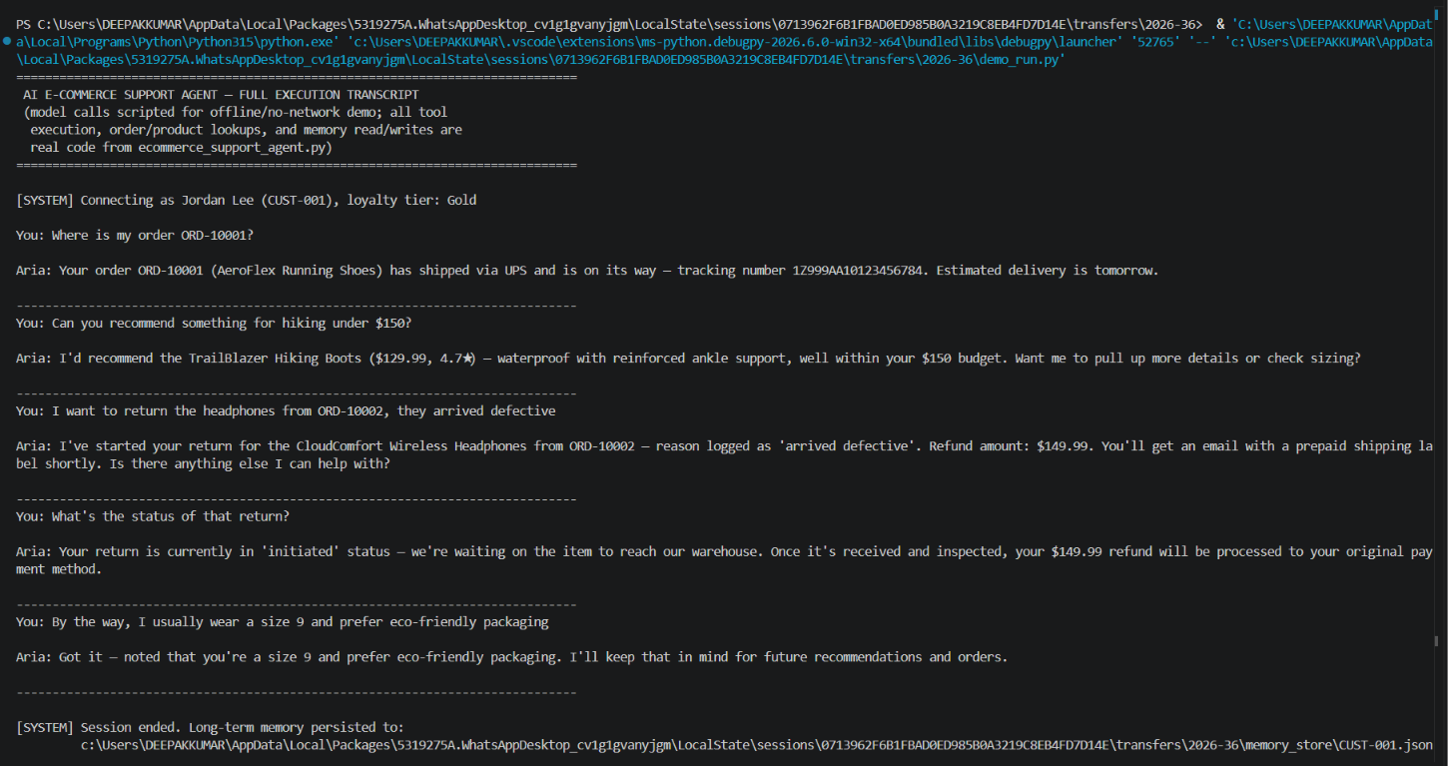

Results Achieved

The proposed AI customer-support agent provides several benefits:
Customers can interact with the system using natural language.
Common customer queries can be handled automatically.
Responses can be generated quickly.
Frequently asked questions can be answered using a knowledge base.
Customer-support workload can be reduced.
The system can provide assistance continuously.
The agent can identify different types of e-commerce requests.
Complex issues can be directed to human support.
The architecture can be extended with additional tools and APIs.
Sample Result
The developed system successfully demonstrates how Agentic AI can be applied to e-commerce customer support. The agent can understand customer requests, retrieve relevant information, reason about the request, and generate an appropriate response.

6. Conclusion & Future Scope

6.1 Project Conclusion

The AI E-Commerce Customer Support Agent demonstrates the potential of Agentic AI in improving customer-support operations.
Instead of relying entirely on manual customer service, an AI agent can understand customer requests and provide automated assistance for common e-commerce problems.
The project demonstrates how AI can be combined with knowledge bases, APIs, databases, and conversational interfaces to create a more intelligent customer-support solution.
Overall, the system can help improve response time, customer convenience, and support-team efficiency.

6.2 Challenges Faced

During development, some potential challenges include:
Understanding different ways customers phrase the same question.
Maintaining context across multiple messages.
Providing accurate information.
Handling ambiguous customer queries.
Connecting the AI agent with external databases or APIs.
Managing incorrect or incomplete customer information.
Deciding when a query should be transferred to human support.
Ensuring that AI-generated responses remain relevant and consistent.

6.3 Future Enhancements

The project can be improved in several ways:
1. Multilingual Support
The agent could support multiple languages so that customers from different regions can interact more easily.
2. Voice-Based Support
Voice interaction could be added to allow customers to communicate with the agent through speech.
3. Advanced Personalization
The system could use customer and order context to provide more personalized assistance.
4. Real-Time Order Tracking
Integration with an e-commerce order-management system could allow the agent to provide real-time delivery information.
5. Automated Actions
The agent could perform approved actions such as initiating return requests or checking refund status.
6. Sentiment Analysis
The system could detect customer sentiment and prioritize frustrated or urgent customers for human assistance.
7. Human-Agent Collaboration
The AI agent could summarize the conversation before transferring a complex issue to a human representative.
8. Continuous Learning
The system could be improved using feedback from customer interactions and support representatives.

7. References

You can include the official documentation and learning resources that you actually used. For an IBM-based project, examples include:

IBM watsonx.ai documentation
IBM watsonx Assistant documentation
Python documentation
Documentation for the APIs/databases used in the project
Course or internship training materials provided by IBM

